First Baptist Regina Weekly News
For the Week of April 24, 2022
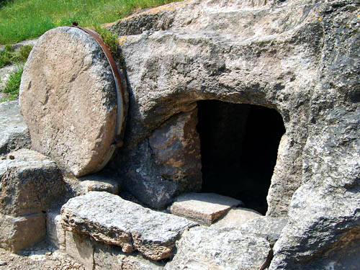
Can you picture the children of our church, sitting in the front pew for their illustration and blessing? And when it is over, getting up and running toward their worship space? It has been wonderful to see children filling up the front pew again some Sundays!
Once they are downstairs and settled again in Godly Play, every week they hear and see a Bible story acted out with little wooden characters. This Sunday, they will hear the story from the Gospel of John, of the empty tomb and of Jesus meeting Mary.
Once they story is finished, we ask wondering questions. “I wonder what Jesus felt when he saw Mary again?” “I wonder how Mary felt when she heard Jesus say her name?” “I wonder if you’ve ever heard Jesus speak to you?”
John tells us that Mary went to the tomb early that Sunday. She was not alone, she said “we went,” though the other women with her were not named. I wonder what they were feeling and thinking? Resignation? Confusion? Peace? The exhaustion after intense grief? Anger? Courage? In the mix of thoughts and feelings within them, they were confronted by an empty tomb. In the midst of all that was going on, beginning with Mary, they met Jesus.
I wonder what you are going through right now? A congregation is always such a mix of experiences, some at the end of life, some at the beginning, some joyful and energized, some worn out, some grieving.
I wonder what you think as you look at the empty tomb?
I wonder if you would say you’ve met Jesus?
Let’s not stop turning to Jesus, day after day. Our Good Shepherd is alive and near us.
Yours in prayer,
Pastor Joel

Our Condolences
We extend our condolences to the family and friends of Kristofer Sotropa, grandson of Vic and Irene Sotropa. After a long struggle with brain cancer, Kristofer passed away peacefully on Friday, April 22nd. Please remember the family in your prayers.

Church Picnic – Sunday, June 19th
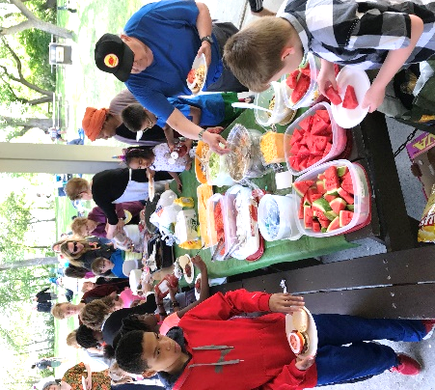
Once again, we can look forward to meeting together for a time of fellowship, games, music, food, and prizes! The picnic will be held on Willow Island from 3:30 to 6:30 p.m.
• Salad and dessert potluck
• Hamburgers, hotdogs, and beverages provided
• Bring lawn chairs or picnic blankets, plates and flatware
• Freewill offering to defray costs
• All ages welcome
• Wheelchair access available – please contact the church to make arrangements.

First Baptist Church Weekend Retreat – September 16-18
Mark your calendars now for our 2022 Fall Retreat at Katepwa Lake Camp. This is a church-wide retreat for all ages. The weekend will include sessions for teaching, reflection, and worship. As well there will be free time and opportunity for deepening our friendships, and finding some rest and renewal. Everyone is welcome!

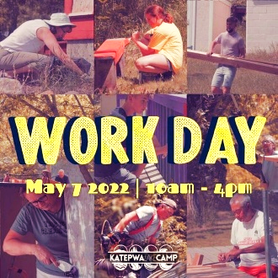
Katepwa Lake Camp Work Day – Saturday, May 7th
May 7th, from 10 am to 4 pm, will be our spring work day. Our camp needs a lot of year-round upkeep, and we're hoping you'll join us as we prep our facilities for the 2022 season! There will be a job for everyone, regardless of your skill level. To sign up, email the camp or call the church at (306) 359-1450, ext. 226. See you there!

Vivace Concert – May 7th
The Vivace Choral Ensemble will present “Spring Reflections” on May 7th, at 7:00 pm, in the sanctuary. For more information or to purchase tickets ($15), visit the Vivace website.

COVID Measures

We are still waiting for COVID to slow down further. Over the coming weeks, we will continue to ask people to wear a mask on Sunday mornings and in larger groups. We will continue to evaluate this week by week.

Update on Ukraine
According to the UN’s refugee agency (UNHCR), more than 5 million people have fled Ukraine; the vast majority of these are women, children and the elderly. There are more than 2.8 million refugees in Poland alone, along with more than 763,000 in Romania, more than 476,000 in Hungary and more than 428,000 in Moldova.
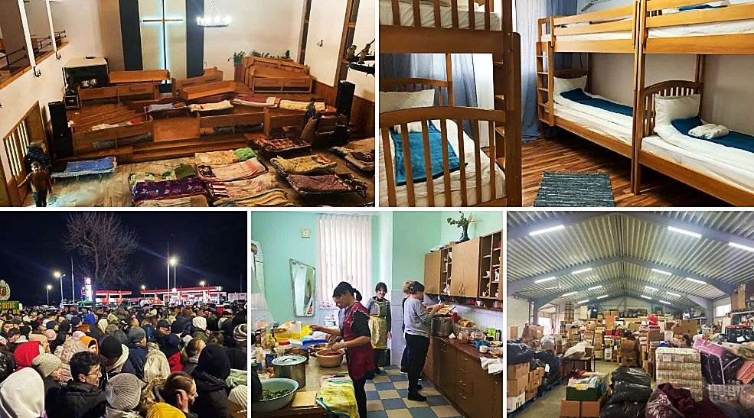
Canadian Baptist Ministries (CBM) continue to help, providing food, clothing, medicine, pastoral care and transportation to refugees. Please continue to pray for the Ukrainian people and every-one involved in helping them.
For more information on how CBM is helping, visit the CBM website - Update on Ukraine.
CBM has an emergency relief fund which we invite you to consider. To donate through this fund, follow this link: CBM emergency relief in Ukraine.

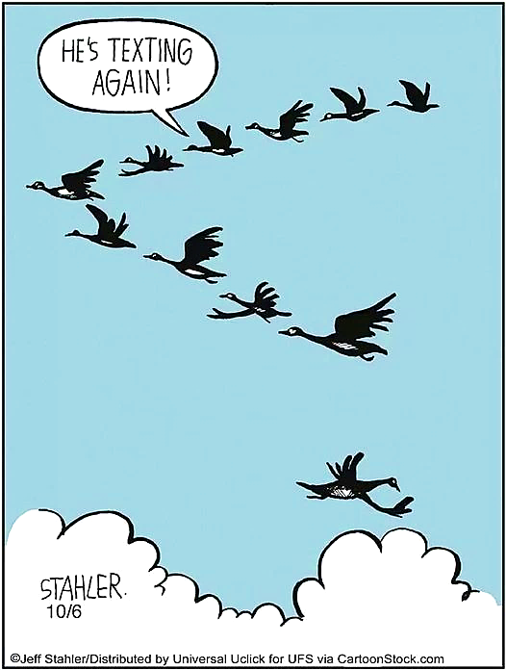
Surprised to see an empty seat at the Super Bowl, a diehard fan remarked about it to a woman sitting nearby.
“It was my husband’s,” the woman explained, “but he died.”
“I’m very sorry,” said the man. “Yet I’m really surprised that another relative, or friend, didn’t jump at the chance to take the seat reserved for him.”
“Beats me,” she said. “They all insisted on going to the funeral.”
“I have to cut down on hot dogs and beer,” one baseball fan said to another.
“Why’s that?”
“Can’t you see?” I’m starting to get a ballpark figure.”

What’s happening at First?

Morning Prayer
Join us each morning, Monday to Thursday at 7:15 am to begin your day with scripture and prayer, via Zoom. Visit our website for the link.

Children’s Ministry
There are in-person classes for children up to Grade 6 during our 11 am worship service. The children are currently working through the Lent and Easter Season stories. For more information, please contact Pastor Kayely.

Youth Ministry
The youth meet once a week. For more information about our youth program, please contact Pastor Chris.

Adult Ministries

Learning for Life (L4L): Annabel Robinson is leading the series: “The Gospel of John.” This whole Gospel is centred on Jesus and who he is. The class will encourage each person to ask themselves, “Who, in my experience, is Jesus?” This class is in person, and also on Zoom. This Sunday’s class will be the last one in this series. For more information, please contact Annabel, email the church, or go to our website. Join Learning for Life.
Learning for Life between Sundays: In this class, facilitated by Joel Russell-MacLean, we read and reflect on the powerful stories and personal presentation of Jesus in the Gospel according to John. Whether Sunday mornings at 9:30 don’t work for you, or if there’s something you want to follow up on after Sunday’s sermon or L4L class, all are welcome. The class is both in person and on Zoom. This Tuesday, April 26th, will be our last class. For more information, visit our website or contact Pastor Joel. Join Weekday L4L.
Voice: A small group for women who like to read and enjoy lively conversation. The group meets every second Wednesday from 7 to 9 pm, using Zoom. For more information, contact Bonnie A-W or Laureen S, call (306) 359-1450, email the church, or visit our website.
Reading through the Pauline Epistles: This group, facilitated by Norma Holtslander, meets every Wednesday, on Zoom, at 10:30 am. For more information, contact Norma or call the church at (306) 359-1450. Join Reading the Pauline Epistles.

Dial-the-Sermon – (306) 992-1912
Know of someone with no computer and/or internet access and cannot come to church in person? Please let them know that there is an easy way to listen to a recent Sunday’s sermon. Simply dial (306) 992-1912 (toll-free within the Regina area) on a landline phone or cell phone. This number takes you straight to the sermon recording.

Tithes and Offerings
Whether you are attending Sunday services in person or online, there are several methods that you can use to give your tithes and donations to the church:
- Mail your gifts to the church or call and leave a message at (306) 359-1450 to arrange for an in-person pick-up. Please place your cheque in your regular offering envelope (or any envelope marked “Offering”), and seal that inside another envelope addressed to: First Baptist Church, 2241 Victoria Ave, Regina, SK S4P 0S4.
- Establish a Pre-authorized Remittance (PAR) Plan. This will automatically transfer funds from your account into the FBC Regina account on a regular basis. Please email the church or contact the Treasurer if you would like to set up PAR, or change your commitment.
- Make an online donation:
- Use a credit or debit card to make a donation from our website. (The church is charged a small processing fee for each donation.)
- Use Interac e-Transfer to donate from your phone or computer to FBCRegina@gmail.com (no fee or cost to the church)
- Use a credit card with a PayPal account via the PayPal Giving Fund (no fee or cost to the church – 100% of your donation reaches us)
- Use a credit card or PayPal via CanadaHelps (a 4% fculatoee is deducted from the donation)
- Use a credit or debit card via FBC ChurchTrac (the church is charged a fee of approximately 3% for each donation)
PLEASE refer to our website at firstbaptistregina.ca for more specific information on these contribution methods. You may also contact the treasurer at (306) 775-1497 or email the church at main_fbcregina@sasktel.net for further details.

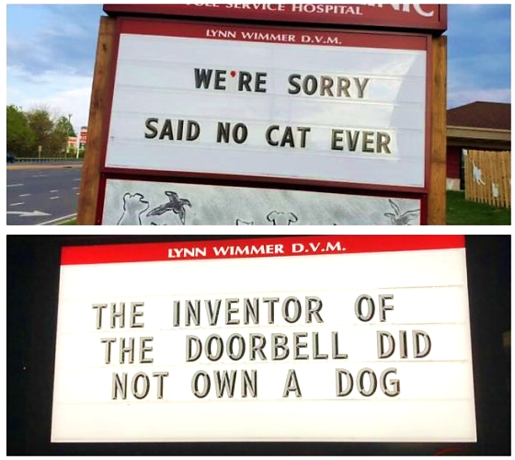
A diner called the waiter over and asked, “What’s this at the bottom of my plate?”
It’s the design,” replied the waiter.
“In that case,” said the diner, “it’s an animated drawing—it’s moving!”
Usually there’s no computer problem I can’t solve. But I met my match when I turned on my machine and was greeted with the message: “Keyboard not detected. Hit any key to continue.”

